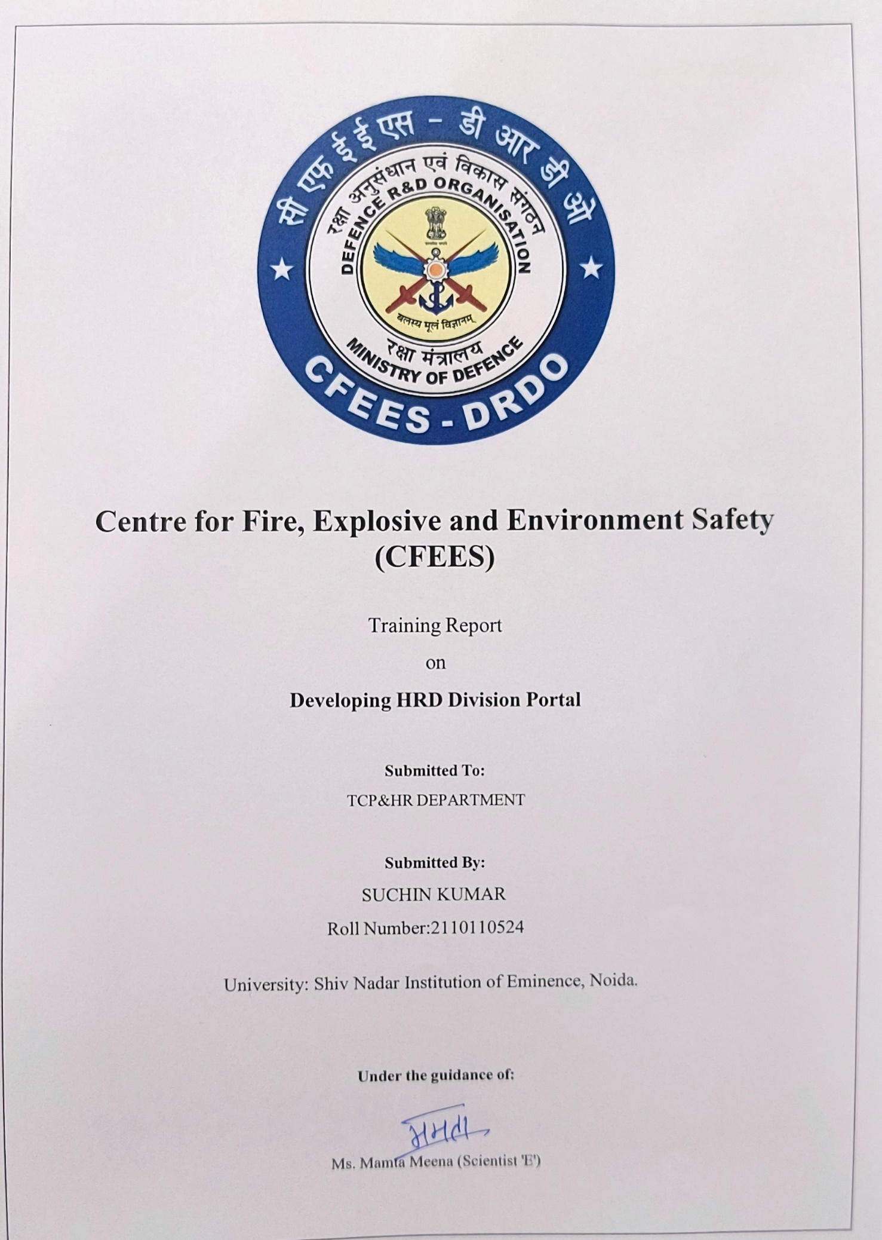

# Certificate

I, Suchin kumar, a student of Bachelor of Technology in Computer Science and Engineering batch of 2021-25, Shiv Nadar Institution of Eminence, Noida.

I now declare that the Summer Training project report titled "Online HRD Division Portal" is original work and has not been submitted to any other institute for the award of any other degree. This report does not contain any confidential information about DRDO. We wish you a bright future.

Ms. Mamta Meena Sc ‘E’ Date: 05/07/2024

# Acknowledgment

I want to extend my heartfelt gratitude to the Defence Research and Development Organisation (DRDO) for providing me with the invaluable opportunity to undertake this training. My sincere thanks go to my project mentor, Ms. Mamta Meena, Scientist 'E', for her continuous guidance and support throughout the training period. I also express my gratitude to my colleagues and the entire team at CFEES, DRDO, for their cooperation and assistance.

I am highly obliged to the TCP&HR Group at CFEES, Delhi, for allowing me to associate with this esteemed establishment as a summer trainee in the "QRS&IT Group" for seven weeks from May 22 to July 5, 2024.

Most importantly, I sincerely thank Ms. Mamta Meena for her unwavering guidance throughout this project's progress and her valuable contribution to the preparation and compilation of this report. Her insights and expertise have been instrumental in completing this training.

I extend my heartfelt gratitude to everyone who has supported me in various ways during my time at CFEES, Delhi. Your encouragement and assistance have been greatly appreciated.

Date: 05/07/2024 Suchin kumar

B. Tech CSE

# Table of Contents

1. Company Profile 1-2
2. Introduction to the Training Project 3
3. Abstract 4
4. Project Description 5-7
5. Technologies Used 8
6. Implementation Details 9
7. Core Functionalities 10-11
8. Code File Explanations 12-15
   * Dashboard
   * Inbox
   * Feedback
   * Status
   * Upload Training
   * View Training
   * Direct Application
9. Workflow 16-19

* Class diagram

1. Challenges and Solutions 20-21
2. Results and Observations 23
3. Conclusions 24
4. Future Directions 25-28
5. References 29

# Company Profile

## Introduction

The Centre for Fire, Explosive, and Environment Safety (CFEES) is an Indian defense laboratory of the Defence Research and Development Organisation (DRDO). Located in Timarpur, Delhi, its main function is the development of technologies and products in the area of explosive, fire, and environmental safety. CFEES is organized under the Armaments Directorate of DRDO. The present director of CFEES is Arvind Kumar.

## History

The Centre for Explosive and Environment Safety (CEES) was established in 1992 by merging three DRDO establishments: DRDO Computer Centre, Delhi, The Directorate of Explosives Safety, DRDO HQ, and the Fire Adviser’s Office, DRDO HQ. In 2000 another DRDO lab, Defence Institute of Fire Research (DIFR) was merged with CEES. To emphasize the importance of fire science, the Government renamed CEES as CFEES in 2003.

## Areas of Work

CFEES works in the areas of Explosive safety, Fire protection, and environmental safety. In addition to developing technologies to protect against these threats, it also trains personnel in these areas and enforces safety standards in the use of hazardous materials: toxic, explosive, and flammable. CFEES also designs and develops sensors to detect these threats.

1. **Explosive Safety** - CFEES helps in the siting of explosive processing and storage dumps and the design, testing, and evaluation of safe explosive storage houses. Additionally, it trains armed forces personnel and DRDO scientists in the safe use of explosives and ordnance and enforces

compliance with safety rules. Simulation and risk modeling are also carried out to aid in Disaster Management.

1. **Environment Safety** - CFEES develops treatment and disposal techniques for hazardous heavy metal wastes, as well as photodegradable polyethylene for use as packaging material at high altitudes, which prevents pollution in mountainous areas where the Indian Army operates, such as Kargil and Siachen.
2. **Fire Safety** - CFEES is involved in the development of automatic fire and explosion detection and suppression systems for armored vehicles, and water mist-based fire protection systems for various applications. It also develops lightweight fire protection clothing. A smoke test tunnel for creating fire signatures under various conditions has been installed. Specialized training for armed forces personnel in fire protection, safety, prevention, and firefighting is also conducted by CFEES. The lab has also developed a software package for virtual firefighting and fire training simulation.

## Vision

To evolve into a Centre of Excellence in the field of Fire Science & Engineering, Explosive, and Environment Safety & to provide integrated safety advice and services to MoD establishments.

## Mission

R&D in Fire Science & Engineering, Explosive, and Environment Safety; Regulatory Authority for Fire, Explosive, and Environment Safety in MoD establishments; and Nodal Agency for Implementation of Safety Healthy Environment (SHE) & Disaster Management for DRDO.

# Online HRD Portal

## Abstract

The Online HRD is a comprehensive web-based application designed to streamline and automate various administrative tasks within the HR division of an organization. Developed over several weeks by a dedicated team of three, the project aimed to reduce paperwork and enhance efficiency in managing requests related to employee attendance at conferences and symposiums.

Key functionalities implemented include a robust backend system for managing and storing course details, allowing HR administrators to add, edit, and delete upcoming events easily. The system features a user-friendly dashboard where employees can view upcoming courses, facilitating informed decision-making regarding their participation.

In addition to course management and reporting, the project incorporated a feedback submission mechanism for conference attendees. This feature allows participants to submit their feedback directly through the system, which is then aggregated and displayed for HR review. Such real-time feedback mechanisms enhance organizational responsiveness and improve the overall participant experience. User training and documentation will also be prioritized to ensure effective utilization of the system across all organizational levels.

In conclusion, the Online HRD represents a significant advancement in HR administration, offering a scalable solution for reducing administrative burdens, improving decision-making processes, and fostering a more agile and responsive organizational culture.

## Chapter1. Introduction

Efficiently managing seminar applications within a corporate environment is crucial for fostering employee development and ensuring smooth operational workflows. Traditional methods involving manual processing through emails and paper forms have led to inefficiencies, lack of transparency, and scalability challenges. To address these issues, this training project aims to develop a web portal for tracking and managing seminar applications within the company, streamlining the submission, review, and approval process.

### Background

The conventional approach to handling seminar applications is fraught with inefficiencies. Manual processing results in time-consuming administrative tasks, frequent delays, and a high risk of errors. Additionally, applicants often face a lack of transparency regarding the status of their submissions, leading to frustration and repeated follow-ups. As organizations grow, these methods become increasingly unsustainable, and the risk to data security rises due to the use of unsecured and disparate systems. Recognizing these challenges, the proposed web portal seeks to centralize and automate the management of seminar applications, thereby improving efficiency, transparency, and scalability while enhancing data security.

### Objective

The primary objective of this project is to develop a web portal that automates the management of seminar applications. The system will support the complete lifecycle of application processing, from submission to final approval, aiming to reduce manual efforts and errors, facilitate efficient decision-making, and enhance user experience.

### Scope

The scope of the project includes:

* **User-Friendly Interface**: Developing an intuitive interface for easy submission of seminar applications.
* **Multi-Level Review Dashboard**: Creating dashboards for various user levels (e.g., AD, TCP_HR_Head, TCP_HR_AD, Director) to review and decide on applications.
* **Tracking Mechanism**: Implementing real-time tracking for applicants to check the status of their submissions.
* **Automated Notifications**: Sending automated email notifications regarding application status updates.
* **Feedback Collection**: Incorporating a feedback module for applicants to provide input on the application process.

### Project Goals

* **Efficiency**: Streamline the application process to reduce time and effort required for management.
* **Transparency**: Provide clear status tracking to improve applicant visibility and reduce follow-ups.
* **Scalability**: Design the system to handle increasing numbers of applications and users effectively.
* **Data Security**: Ensure robust protection of sensitive information through encryption and secure access controls.
* **User Experience**: Deliver a responsive and intuitive interface that facilitates a smooth and efficient user interaction.

This project aims to modernize the seminar application process by developing a centralized, automated, and user-friendly system, addressing current inefficiencies, enhancing transparency, and supporting future growth and security requirements.

## Chapter2. Project Description

The project involved developing a web portal that allows employees to submit applications for seminars, workshops, and conferences. The portal also provides functionalities for higher- level users to review, approve, or reject these applications, and allows applicants to track the status of their submissions.

### System Architecture

The system is designed using three-tier architecture:

* **Presentation Layer:** The user interface, which includes web pages built with HTML, CSS, and JavaScript.
* **Business Logic Layer:** The server-side scripting, implemented using PHP, which handles application logic and database interactions.
* **Data Layer:** The database, managed using MySQL, which stores application data and user information.

### User Roles

* **Applicant:** Can submit applications, view the status of their applications, and provide feedback.
* **Reviewer:** Can review submitted applications, approve or reject them, and send feedback to applicants.
* **Administrator:** Can manage user accounts, oversee application processing, and generate reports.

### Functional Modules

* **Application Submission:** Allows users to submit new applications for seminars.
* **Dashboard:** Provides an overview of user activities and links to other functionalities.
* **Inbox:** Displays messages and notifications to users.
* **Feedback:** Enables users to submit and view feedback.
* **Status Tracking:** Allows users to check the status of their applications.
* **Training Management:** Allows administrators to upload and view training details.
* **Direct Applications:** Facilitates direct applications for seminars.

### Key Components:

1. **User Interface:**
   * dashboard.php: Main user interface for the dashboard.
   * login.php: Login page for users.
   * register.php: Registration page for new users.
   * new_application.php: Interface to submit a new application.
   * view_application.php: Interface to view submitted applications.
   * print_application.php: Interface to print application details.

### Scripts and Styles:

* + login_script.js, register_script.js, dashboard_script.js: JavaScript files for handling frontend logic.
  + styles.css, dashboard_styles.css, login_styles.css, register_styles.css, new_application.css: CSS files for styling the application.

### Backend Logic:

* + approve.php: Logic for approving applications.
  + reject.php: Logic for rejecting applications.
  + manage_application.php: Logic for managing applications.
  + status.php: Logic for checking the status of applications.
  + logout.php: Logic for logging out users.

## Chapter3. Methodology Used

The development of the online HRD system follows a methodical approach designed to ensure user-centricity, data efficiency, and security.

* **Requirements Gathering and Analysis** starts with in-depth stakeholder interviews to capture functional and non-functional requirements, creating detailed use cases and documenting expectations to establish a clear project scope.
* **User-Cantered Design** involves crafting initial wireframes and high-fidelity prototypes of the user interface, followed by iterative testing and refinement based on user feedback to enhance usability and accessibility.
* **System Architecture Design** defines the technical framework, including a well- structured component diagram, an optimized database schema for efficient data handling, and a robust security architecture featuring encryption, secure authentication, and access controls.
* **Development and Implementation** integrates backend server logic, database interactions, and the hierarchical approval workflow with a responsive, user-friendly frontend interface, ensuring cohesive functionality and seamless data flow.
* **Testing** includes rigorous unit, integration, and user acceptance testing (UAT), alongside comprehensive security assessments to validate functionality, performance, and safeguard against vulnerabilities.
* **Deployment** involves setting up the production environment, deploying the system with minimal disruption, and establishing monitoring to ensure reliable performance and availability in a live setting.
* **Maintenance and Support** ensure ongoing system effectiveness through issue tracking, regular updates to address emerging needs, and user support for continuous improvement and alignment with evolving organizational requirements.

This streamlined methodology ensures the online HRD system is developed with a focus on usability, efficiency, and robust security, delivering a reliable solution for managing HRD activities and user interactions.

## Chapter4. Technology Used

The online HRD system leverages a combination of modern technologies and tools to deliver a robust, user-friendly, and secure platform. The chosen technology stack ensures effective development, seamless user interaction, efficient data management, and strong security practices.

### Hardware Requirements

To support the development, deployment, and operation of the online HRD system, the following hardware components are essential:

* + 1. **Development Workstations**: Modern computers or laptops with at least:
       - **Processor**: Intel Core i5 or AMD equivalent
       - **Memory**: 8 GB RAM (16 GB recommended)
       - **Storage**: 256 GB SSD (512 GB recommended)
       - **Operating System**: Windows 10/11, macOS, or Linux
    2. **Server Infrastructure**: For hosting the system:
       - **Processor**: Quad-core CPU (Intel Xeon or AMD equivalent)
       - **Memory**: 16 GB RAM (32 GB recommended for larger scale)
       - **Storage**: 512 GB SSD (RAID configuration recommended for redundancy)
       - **Operating System**: Linux
    3. **Network Requirements**: Stable and high-speed internet connectivity with a reliable network infrastructure to support remote access and data transfer.

### Software Requirements

The software ecosystem for developing and deploying the online HRD system includes various tools and frameworks:

### Frontend Development:

* + - * **HTML/CSS**: For structuring and styling the user interface.
      * **JavaScript**: For adding interactivity and dynamic behavior to the frontend.
      * **Bootstrap**: pre-defined form Templates.

### Backend Development:

* + - * **PHP**: Server-side scripting language used for developing backend logic, handling database interactions, and managing the hierarchical approval workflow.

### Database Management:

* + - * **MySQL:** Relational database management system for storing and managing application data, including user information, event details, applications, and feedback.
      * **PhpMyAdmin**: Database Administrator Tool.

### Development Tools:

* + - * **Visual Studio Code (VS Code)**: Integrated Development Environment (IDE) for writing, debugging, and managing code.
      * **GitHub**: Version control platform for source code management.

### Deployment and Hosting:

* + - * Hosted the Software on the laboratory’s Intranet Server.

## Chapter5. Implementation

The implementation of the project involved several stages, including requirement analysis, system design development, testing, and deployment.

### Requirement Analysis

This stage involved understanding the needs of the users and defining the functionalities required for the system. Meetings were held with stakeholders to gather requirements and create detailed specifications.

### System Design

Based on the requirements, a system design was created. This included defining the system architecture, database schema, and user interfaces. Wireframes and mock-ups were created to visualize the user interfaces.

### Development

during the development stage, the system was built according to the design specifications. The development process was divided into several iterations, with each iteration focusing on a specific module or functionality.

### Testing

the system was rigorously tested to ensure it met the requirements and was free of bugs. Testing involved unit testing, integration testing, and user acceptance testing. Feedback from users was incorporated to improve the system.

### Deployment

Once the system was thoroughly tested and approved, it was deployed to a production environment. Training sessions were conducted to familiarize users with the new system, and support was provided to address any issues that arose.

### Core Functionalities

The core functionalities of the system are divided into several modules, each serving a specific purpose. These modules work together to provide a seamless experience for users.

### Application Submission

This module allows users to submit new applications for seminars, workshops, and conferences. Users can fill out a form with the necessary details, such as the seminar title, description, date, and other relevant information.

### Dashboard

The dashboard provides an overview of user activities and links to other functionalities. It displays user-specific information, such as recent applications, messages, and notifications. It serves as the main interface for users to navigate the system.

### Inbox

The inbox displays messages and notifications to users. Users can view, delete, or respond to messages. This module ensures that users stay informed about the status of their applications and receive important updates.

### Feedback

The feedback module allows users to submit and view feedback. Users can provide feedback on the application process or the seminars they have attended. This feedback is stored in the database and can be viewed by administrators.

### Status Tracking

This module allows users to check the status of their submitted applications. Users can view the current status, such as pending, approved, or rejected, and any feedback provided by reviewers.

### Training Management

The training management module allows administrators to upload and view training details. This includes information about upcoming training sessions, seminars, and workshops. Administrators can add, edit, or delete training details.

### Direct Applications

This module facilitates direct applications for seminars. Users can submit applications directly without going through the regular application process. This is useful for special cases where immediate approval is required.

### 1 .Code File Explanations Dashboard

The dashboard serves as the main user interface where users can see an overview of their activities. It provides quick access to various functionalities like submitting new applications, checking the status of existing applications, and providing feedback. The dashboard is designed to be user-friendly and informative, ensuring that users can easily navigate and perform their tasks efficiently.

### Significance:

The dashboard is crucial because it acts as the central hub for users. It consolidates all essential actions and information in one place, making it easier for users to manage their activities. By providing a clear and organized interface, the dashboard enhances the overall user experience and productivity.

### Inbox

The inbox displays messages and notifications to users. It is an essential part of the communication system within the portal, allowing users to stay informed about the status of their applications and receive important updates from reviewers and administrators. Users can read, delete, or respond to messages, ensuring effective communication.

### Significance:

The inbox ensures that users are always updated about their application status and other important notifications. Effective communication is key to the smooth operation of any system, and the inbox facilitates this by providing a dedicated space for messages and notifications.

### Feedback

The feedback module allows users to provide feedback on their experiences with the application process or the seminars they have attended. This feedback is valuable for administrators to understand user experiences and make necessary improvements. Users can also view the feedback they have submitted.

### Significance:

Feedback is essential for continuous improvement. By collecting and analyzing user feedback, administrators can identify areas for enhancement and make informed decisions to improve the system. This module ensures that user voices are heard and considered in the development process.

### Status

The status module allows users to track the progress of their submitted applications. It provides real-time updates on the status, such as pending, approved, or rejected, and any feedback provided by reviewers. This transparency ensures that users are always aware of the current state of their applications.

### Significance:

Transparency in the application process builds trust and reduces uncertainty for users. The status module provides this transparency, allowing users to monitor their applications and understand the review process. This helps in managing user expectations and reducing anxiety.

### Upload Training

The upload training module enables administrators to upload details of upcoming training sessions, seminars, and workshops. This information is then made available to users, who can view and register for these events. The module includes forms for entering details like title, description, and date of the training.

### Significance:

By allowing administrators to upload training details, this module ensures that all relevant information is easily accessible to users. It streamlines the process of managing and disseminating information about training events, making it easier for users to find and participate in relevant sessions.

### View Training

The view training module allows users to view the details of the trainings they have uploaded or participated in. It fetches training details from the database and displays them in a user- friendly format. This module ensures that users have easy access to their training history and upcoming events.

### Significance:

Access to training details is important for users to keep track of their professional development activities. This module provides a convenient way for users to view and manage their training records, helping them stay organized and informed.

### Direct Application

The direct application module allows users to submit direct applications for seminars, workshops, or conferences. It provides a form to input application details and stores them in the database. This module is particularly useful for special cases where immediate approval is required.

### Significance:

The direct application module provides flexibility in the application process. By allowing direct applications, it accommodates special cases and urgent requests, ensuring that users can quickly apply for and attend important events. This module enhances the system's responsiveness and user satisfaction.

## Chapter6. Workflow

The workflow of the system involves several steps, starting from the submission of an application to its final approval or rejection. The process is designed to be straightforward and user-friendly, ensuring that users can easily navigate and complete their tasks.

1. **Submission:** Users submit new applications through the application submission module.
2. **Review:** Reviewers receive notifications and review the submitted applications.
3. **Feedback:** Reviewers provide feedback and either approve or reject the applications.
4. **Notification:** Users receive notifications about the status of their applications.
5. **Tracking:** Users can track the status of their applications through the status module.
6. **Feedback Submission:** Users can provide feedback on the process and the seminars they attend.

This workflow ensures a smooth and efficient application process, with clear communication and transparency at each step. (Shown in Fig.1)

### PlantUML class diagram for the described online HRD (Human Resource Development) system:

@startuml

:User: as User

:Application: as Application

:AD: as AD

:TCP_HR_Head: as TCP_HR_Head

:TCP_HR_AD: as TCP_HR_AD

:Director: as Director

User -> Application: Apply for Event Application --> User: Application submitted

User -> Application: Give Feedback Application --> User: Feedback submitted

User --> AD: Submit Application

AD --> Application: Review Application if (Approved?) then (yes)

AD --> TCP_HR_Head: Submit to TCP HR Head TCP_HR_Head --> Application: Review Application if (Approved?) then (yes)

TCP_HR_Head --> TCP_HR_AD: Submit to TCP HR AD TCP_HR_AD --> Application: Review Application

if (Approved?) then (yes)

TCP_HR_AD --> Director: Submit to Director Director --> Application: Review Application if (Approved?) then (yes)

Application --> User: Application Approved

User --> Application: Show Successful Popup else (no)

Director --> Application: Reject Application Application --> User: Application Rejected endif

else (no)

TCP_HR_AD --> Application: Reject Application Application --> User: Application Rejected

endif else (no)

TCP_HR_Head --> Application: Reject Application Application --> User: Application Rejected

endif else (no)

AD --> Application: Reject Application Application --> User: Application Rejected endif

@enduml

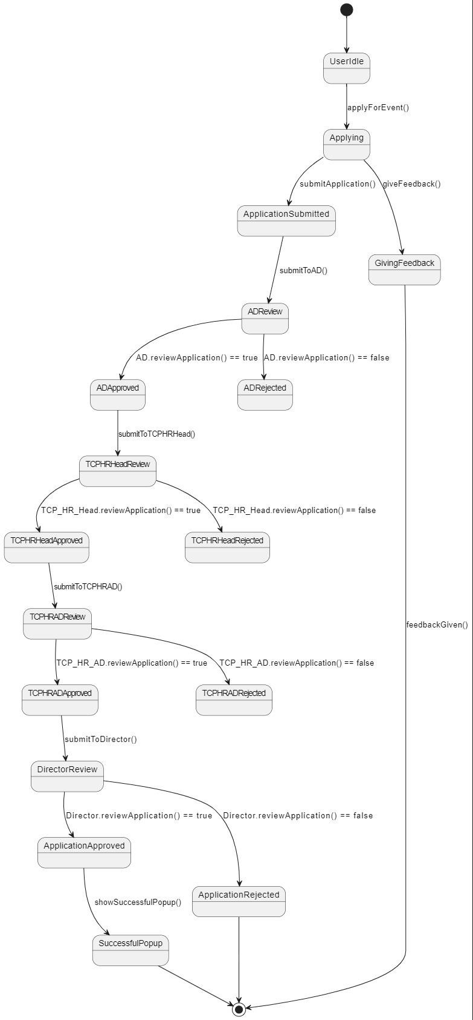

Fig. 1

## Chapter7. Challenges and Solutions

### Challenges:

To address the challenges and solutions related to user interface design, database management, and security in software systems:

### User Interface Design:

* + Ensuring a user-friendly interface that meets the needs of diverse users can be challenging. Different users may have varying levels of technical proficiency and preferences for interface design.

### Database Management:

* + Efficiently managing a large volume of data while ensuring data integrity (accuracy and consistency) poses challenges. Performance issues can arise if queries are not optimized or if the database schema is not well-designed.

### Security:

* + Protecting user data and ensuring secure access to the system are critical. Security threats such as unauthorized access, data breaches, and malware attacks are significant concerns that need to be addressed.

### Solutions:

1. **Iterative Design Process**:
   * **Solution**: Use an iterative design process to continuously improve the user interface based on user feedback. Conduct usability testing and gather user input to refine interface elements, navigation flows, and overall user experience.

### Optimized Queries:

* + **Solution**: Implement optimized database queries and indexing strategies. This helps improve query performance, reduce database load, and enhance scalability. Regularly review and optimize database schema for better efficiency.

### Security Measures:

* + **Solution**: Implement robust security measures such as data encryption, secure authentication mechanisms (e.g., multi-factor authentication), and role-based

access controls (RBAC). Conduct regular security audits and updates to address vulnerabilities and ensure compliance with security standards.

By implementing these solutions, software systems can enhance usability, improve database performance, and strengthen security measures to protect user data effectively.

Addressing the challenges of user interface design, database management, and security in software systems requires a proactive and holistic approach. By adopting iterative design processes, optimizing database management practices, and implementing robust security measures, organizations can enhance user experience, ensure efficient data handling, and fortify system resilience against security threats. These strategies not only mitigate risks but also contribute to the overall reliability, performance, and trustworthiness of software systems in today's digital landscape.

## Chapter8. Results and Observations

The Online HRD system was successfully implemented and deployed, achieving its primary objectives of automating and enhancing efficiency in managing seminar applications within the organization. Key results and observations from the implementation phase include:

### Improved Efficiency:

The implementation of Online HRD has streamlined the process of managing seminar applications, reducing the manual effort and time previously required. By automating tasks such as application submission, approval routing, and status tracking, the system has enabled HR administrators to focus more on strategic activities rather than administrative tasks.

### Enhanced Transparency:

Users have noted a significant improvement in transparency throughout the application process. With the introduction of a user-friendly dashboard, employees can now easily submit their applications and track the progress in real-time. Clear notifications and status updates ensure applicants are informed promptly about any changes or updates to their application status, enhancing overall transparency and reducing ambiguity.

### Positive Feedback:

Feedback from users has been overwhelmingly positive, particularly regarding the system's user interface and efficiency. Employees appreciate the intuitive design of the application submission form and dashboard, which simplifies the process of submitting seminar applications. The ability to receive automated notifications and updates on application status has been highlighted as a significant improvement compared to previous manual processes.

### Operational Impact:

Operationally, Online HRD has had a transformative impact on the HR division's operations. By centralizing application management and standardizing approval workflows, the system has minimized errors and delays. HR administrators now have access to comprehensive reporting and analytics, facilitating informed decision-making and resource allocation for future seminars and training events.

### Scalability and Future Enhancements:

The system's architecture and design allow for scalability and future enhancements. As the organization grows and requirements evolve, Online HRD can accommodate additional functionalities such as advanced analytics, integration with external HR systems, and enhanced reporting capabilities. These future enhancements aim to further optimize HR processes and support the organization's strategic objectives.

## Chapter9. Conclusion

The training project was a valuable learning experience, providing insights into web development, database management, and user experience design. The system developed during this project has the potential to significantly improve the management of seminar applications within the company, ensuring efficiency, transparency, and user satisfaction.

The implementation of Online HRD represents a significant milestone in enhancing the efficiency and transparency of seminar application management within our organization's HR division. Through meticulous planning, development, and deployment, Online HRD has successfully addressed key challenges associated with manual application processes, delivering tangible benefits and positive outcomes.

In conclusion, Online HRD has proven to be a robust solution for modernizing HR operations, improving efficiency, and fostering a more transparent and responsive organizational culture. By leveraging technology to automate and streamline seminar application management, the system has demonstrated its value in supporting organizational growth and strategic objectives. As we continue to evolve and adapt, Online HRD will play a crucial role in driving operational excellence and empowering our workforce for future success.

The journey of implementing Online HRD has not only transformed our HR processes but has also set a precedent for embracing innovation and leveraging technology to enhance organizational effectiveness. With its proven capabilities and user-centric design, Online HRD stands poised to continue driving positive change and delivering measurable outcomes for our organization.

## Chapter10. Future-directions

The successful deployment of Online HRD has established a solid foundation for enhancing HR operations. Building on its current capabilities, several key areas for future development and enhancement have been identified to further optimize HR processes and support organizational growth. These directions aim to leverage emerging technologies and user feedback to ensure that Online HRD remains a vital tool in our HR arsenal.

### Advanced Analytics and Reporting

* + **Predictive Analytics:** Implementing machine learning algorithms to analyze historical data and predict future trends in seminar attendance and employee participation. This will help in better planning and resource allocation, ensuring that seminars and training sessions are well-attended and effectively meet employee needs.
  + **Customizable Reports:** Enhancing the reporting module to allow HR staff to create and customize reports based on various parameters such as date ranges, course names, and department-specific data. This will provide deeper insights into employee development trends and the impact of training programs.
  + **Real-Time Dashboards:** Developing real-time dashboards with interactive visualizations to monitor key performance indicators (KPIs) and seminar metrics. These dashboards will enable HR managers to quickly assess the effectiveness of training programs and make data-driven decisions.

### Integration with Existing Systems

* + **HRMS Integration:** Integrating Online HRD with the existing Human Resource Management System (HRMS) to facilitate seamless data exchange. This integration will streamline workflows, reduce data duplication, and ensure consistency across different HR modules.
  + **Third-Party System Integration:** Exploring partnerships with third-party platforms and services to enhance functionality, such as integrating with Learning Management

Systems (LMS) for a seamless learning experience or incorporating video conferencing tools for virtual seminars.

### Enhanced User Experience

* + **Mobile Accessibility:** Developing a mobile application or enhancing the existing web interface to ensure that users can access Online HRD from any device, including smartphones and tablets. This will increase accessibility and convenience for users on the go.
  + **Personalized User Interface:** Implementing AI-driven personalization features to tailor the user interface and content based on individual user preferences, roles, and past interactions. This will enhance user engagement and satisfaction.
  + **User Training and Support:** Expanding the training program to include online tutorials, webinars, and interactive guides. Providing comprehensive user support through chatbots, helpdesk services, and an extensive knowledge base will further enhance user experience.

### Feedback and Continuous Improvement

* + **Advanced Feedback Analysis:** Incorporating sentiment analysis and text mining techniques to analyze feedback submitted by conference attendees. This will help in identifying trends, strengths, and areas for improvement in seminar content and organization.
  + **Feedback Loop Mechanism:** Establishing a continuous feedback loop where users can suggest improvements and new features. Regularly updating the system based on user feedback will ensure that Online HRD evolves to meet changing needs and expectations.

### Scalability and Performance

* + **Cloud Scalability:** Migrating to a cloud-based infrastructure to enhance scalability, reliability, and performance. This will ensure that Online HRD can handle increasing user loads and data volumes without compromising performance.
  + **Performance Optimization:** Conducting regular performance audits and optimizing system architecture to ensure fast response times and smooth user experiences, even during peak usage periods.

### Security and Compliance

* + **Enhanced Security Measures:** Implementing advanced security protocols, including encryption, multi-factor authentication, and regular security audits, to protect sensitive employee data and ensure compliance with data protection regulations such as GDPR and CCPA.
  + **Compliance Updates:** Keeping the system updated with the latest compliance requirements and industry standards to ensure that all HR processes are legally compliant and secure.

## References

1. W3Schools, "HTML and CSS Documentation," [Online]. Available: https:/[/www](http://www.w3schools.com/html/).[w3schools.com/html/.](http://www.w3schools.com/html/) [Accessed: 25-May-2024].
2. Mozilla Developer Network, "JavaScript Documentation," [Online]. Available: <https://developer.mozilla.org/en-US/docs/Web/JavaScript>. [Accessed: 8-Jun-2024].
3. The PHP Group, "PHP Documentation," [Online]. Available: [https://www.php.net/docs.php.](https://www.php.net/docs.php) [Accessed: 15-Jun-2024].
4. Oracle Corporation, "MySQL Documentation," [Online]. Available: [https://dev.mysql.com/doc/.](https://dev.mysql.com/doc/) [Accessed: 18-June-2024].
5. Bootstrap, "Bootstrap Documentation," [Online]. Available: https://getbootstrap.com/docs/. [Accessed: -20-Jun-2024].
6. GitHub, Inc., "GitHub Documentation," [Online]. Available: [https://docs.github.com/en.](https://docs.github.com/en) [Accessed: 25-Jun-2024].
7. Microsoft, "Visual Studio Code Documentation," [Online]. Available: [https://code.visualstudio.com/docs.](https://code.visualstudio.com/docs) [Accessed: 28-Jun-2024].
8. NGINX, Inc., "NGINX Documentation," [Online]. Available: https://nginx.org/en/docs/. [Accessed: 28-Jun-2024].

This report offers a detailed examination of the training project, encompassing every facet from the company profile to the system's implementation and outcomes. It provides an extensive analysis of the code files and their respective roles, guaranteeing a comprehensive understanding of the developed system. Each section is meticulously crafted to elucidate the processes involved, the technical decisions made, and the impact of the system on the organization’s operations, thereby providing a holistic view of the project's achievements and its contributions to the organizational goals.